Is My Job Safe?
Uncovering the Impact of AI Adoption on the US Labor Market Using Agent Based Modeling

Steve Eisner
Loyola University of Maryland
DS 795: Data Science Project Design
Dr. Bu H Lee

- Project Background and Data Sponsor

Since its release in November 2022, OpenAI’s ChatGPT has changed the way people think and learn. Now, many model iterations later and with many more companies such as Google, Meta, and Anthropic offering their own AI tool suites, it seems that AI, in some form, is here to stay. Nevertheless, seemingly every evangelist is offset by a hardline opponent fearing the potential negative impact on the environment, security, and the economy. In and amongst all of these fears, it seems that many grapple with the same, most practical question: “Is my job safe?”
Some of the most recent research into the effects of AI adoption on US jobs suggests that “the aggregate impacts of AI-labor substitution on employment and wage growth in more exposed occupations and industries is currently too small to be detectable” (Acemoglu et al. 2022). While studies like this may be reassuring, they often fail to account for or predate the rise of generative AI. Meanwhile, more recent studies on AI’s effects so far between 2022 and 2025 show that occupational mix, a measure historically used to measure instability in the labor market, has increased (Gimbel et al. 2025). While interesting, this study which lacks peer review makes no claims regarding what will happen in the future, only examining current data with no vehicle for projection.
The goal and purpose of this project is to fill some of these gaps, projecting the likely impact of AI adoption on the US labor market at least five years into the future. Due to the complexity of the system, standard models such as linear regression are at significant risk of over-fitting any results we might find. Therefore, this project will attempt to implement Agent-Based Simulation (ABS) to create both a control simulation, where no jobs are at risk due to AI, and an experimental, where an AI risk factor is introduced to a pool of ~10,000 agents acting as real workers in a digital twin of the labor market.
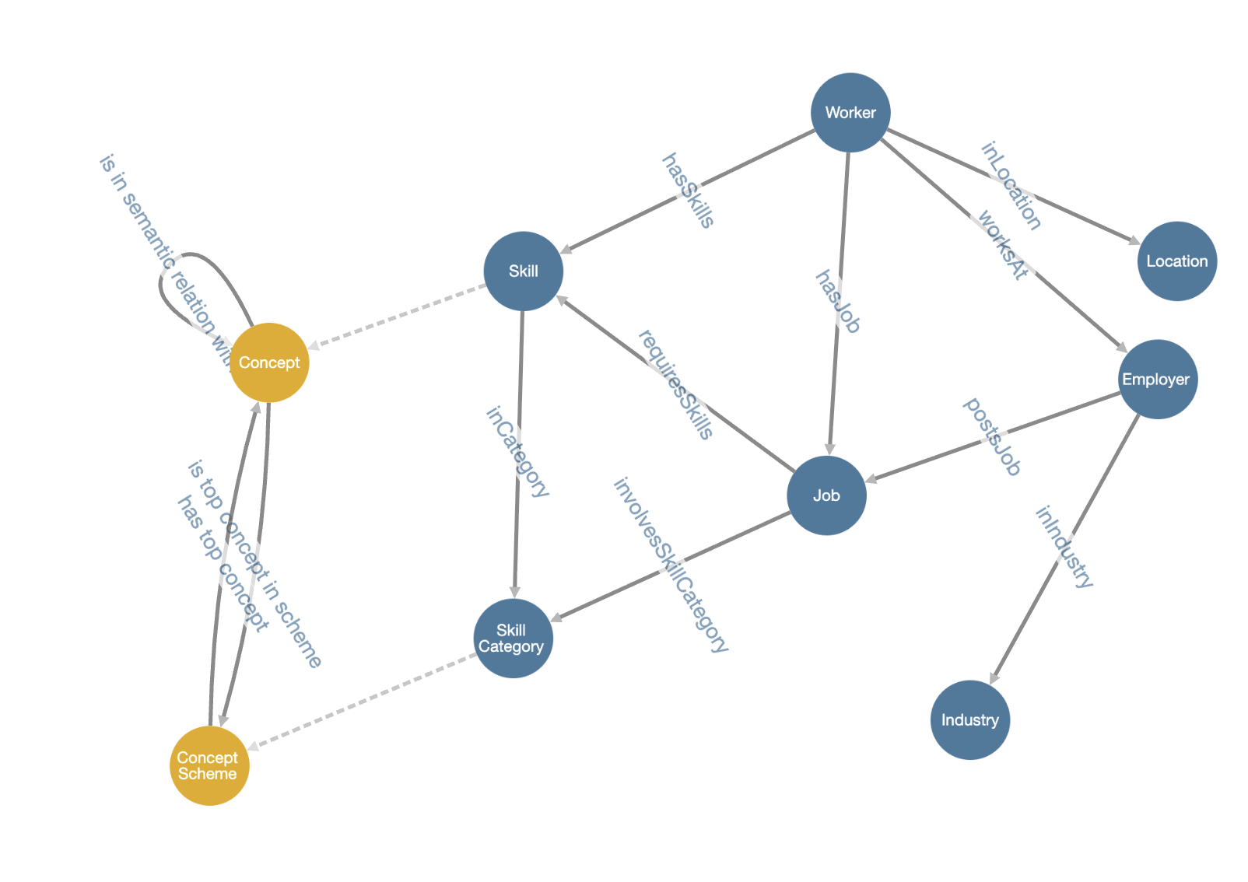
Figure 1. This backing ontology will help inform how different elements of the simulation interact with one another.

While using this graph helps understand some of the interplay, some of the complexity has been abstracted away. For example, understanding how workers move from job to job requires an understanding of how different skills overlap and relate to each other as well as the independent automation and augmentation scores of those skills.
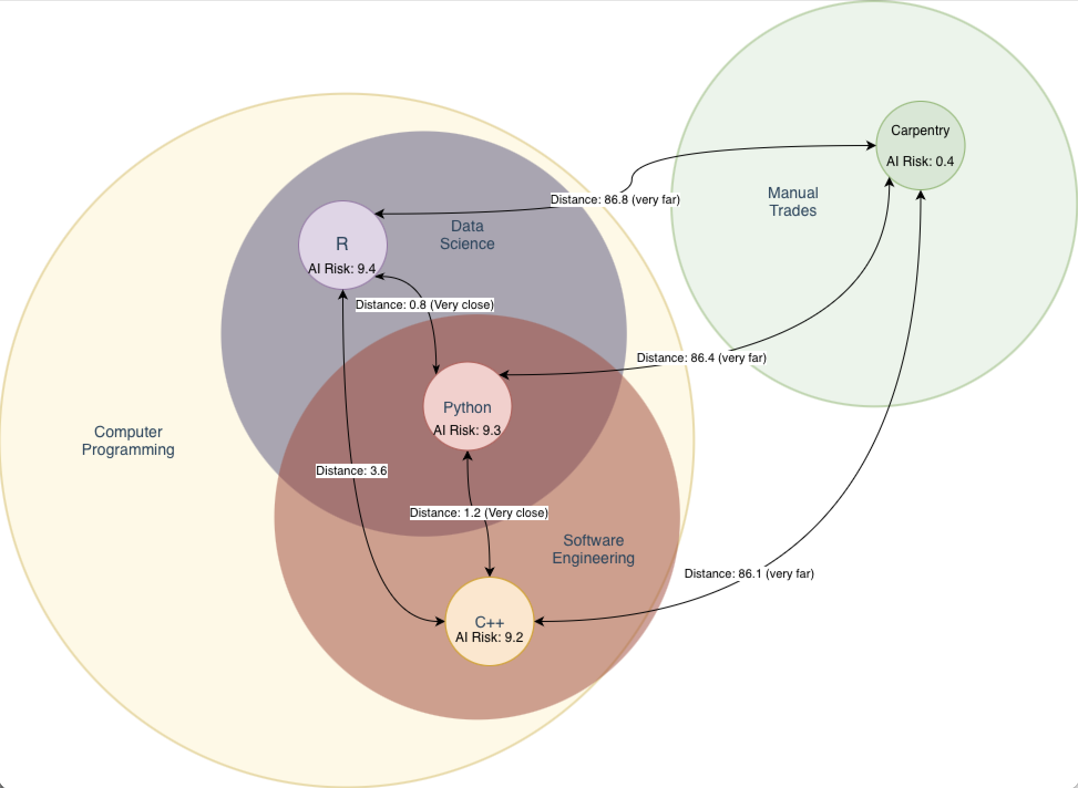
Figure 2. Highlighting how different skills fall into larger, sometimes overlapping, skill categories as well as the AI Risk scores of individual skills. Similar skills will have smaller distances.
This complex analysis allows for this project to simultaneously answer multiple business questions in parallel. A brief list of some of the questions this simulation should be able to answer includes:
- How does the impact of AI adoption on either the macro (US Labor Market) or micro (aggregating across industries) scale change in terms of both jobs and wages, projecting five years into the future?
  - Current Hypothesis: Unemployment Metrics should not deviate between control and experimental groups (Acemoglu et al. 2022).
- What is the vulnerability gap between an entry-level worker and a senior level worker in the same occupation?
  - Current Hypothesis: An entry-level worker is at significantly increased risk of lay-off and will face significantly larger periods of time between jobs, as AI is more capable of automating the routine tasks that are often assigned to junior employees (Brynjolfsson et al. 2025).
- What impact does AI adoption have on the wage gap between entry-level and senior-level workers?
  - Current Hypothesis: The wage gap will widen, as the productivity gains from AI augmentation primarily benefit experienced workers whereas entry-level employees may stagnate due to decreased demand (Brynjolfsson et al. 2025).
- Does AI de-value routine, hard skills such as programming and technical writing?
  - Current Hypothesis: AI adoption will lead to a devaluation of routine, hard skills as these tasks are highly susceptible to automation by Large Language Models (LLMs) (Eloundou et al. 2023).
- What effect is stronger? Automation (AI replaces a human worker) or augmentation (AI makes a human worker more productive, increasing wages)?
  - Current Hypothesis: Experienced workers will experience augmentation as a stronger force whereas junior workers will experience automation as a stronger force (Acemoglu, 2024).
- What rate of new economy job creation (e.g. AI Auditors, Prompt Engineers, etc.) is required to fully offset workers displaced by AI and maintain stable unemployment metrics?
  - Current Hypothesis: The ratio of new roles created per displaced role must be greater than 1.0 to offset displacement due to frictional unemployment and skills mismatches (Occhipinti et al. 2025).
- Is there an AI adoption tipping point where labor demand for a specific industry spontaneously and non-linearly collapses (reduction in vacancies > 20% in a single tick)?
  - Current Hypothesis: Specific industries with high exposure to generative AI will exhibit a non-linear collapse in labor demand once AI tool adoption reaches a critical saturation point of 40-50% (Gimbel et al., 2025)
- Would the negative impact of AI be offset by a program that helped workers retrain into less exposed industries (e.g. government retraining subsidy)?
  - Current Hypothesis: A subsidized retraining program will significantly mitigate long-term unemployment and wage inequality by reducing the friction of transitioning workers from declining, high exposure fields to growing, low exposure fields (World Economic Forum, 2025).

While the data sources in question will help shape and train this digital twin for accuracy, there is no real-world measure for AI Risk, partially because this is a question of opinion rather than fact. To account for this, the AI automation risk scores, AI augmentation chance scores, and skill distances will be generated as the output of a call to an open-source generative AI model. For example, to determine the associated risk of automation removing the need for a worker to have a specific skill, this prompt which has been constructed for this project would generate the data:

“You are an expert in labor economics and artificial intelligence. Your task is to evaluate a specific human "Ability," "Skill," or "Knowledge" item on a scale of 0 to 10. A score of 0 means the item is LOW RISK and very difficult to automate with current (2025-era) Generative AI. A score of 10 means the item is HIGH RISK and very easy to automate or replace.

Score 0-2 (Low Risk): Physical, sensory, or deeply human-interactive skills.
(e.g., 'Manual Dexterity', 'Gross Body Coordination', 'Social Perceptiveness')
Score 5-6 (Medium Risk): Complex cognitive skills that can be augmented but not fully replaced.
(e.g., 'Critical Thinking', 'Speaking', 'Active Listening', 'Management of Personnel')
Score 9-10 (High Risk): Routine cognitive, rule-based, or information-synthesis tasks.
(e.g., 'Written Comprehension', 'Information Ordering', 'Memorization', 'Clerical')

You will be given a skill and must respond ONLY with a valid JSON object in the format:
{"skill_name": "Name of the Skill", "ai_risk_score": X.X}”

This project requires no data sponsor, as all the datasets involved are publicly accessible. There are, however, certain key stakeholders for whom this research may prove more impactful. For example, recent research suggests that the impact of AI adoption may be more visible if examined from the perspective of experience, with leading hypotheses suggesting that “inexperienced workers (0-5 years) bear significantly more of the impact” (Brynjolfsson et al. 2025). Entry level workers could therefore be considered a significant stakeholder group for this research.

- Source and Nature of the Data

As previously mentioned, the three datasets in question are publicly accessible:

IPUMS CPS (Current Population Survey): This is the primary data source that will be used to create the agents in the simulation. IPUMS CPS provides harmonized microdata from the US labor force survey, allowing for the creation of agents with statistically representative demographic and employment characteristics (Flood et al. 2025). The selected data dates back in time to 2010, well before the current advancements in generative AI and covering enough time so outliers such as the pandemic can be accounted for. From the IPUMS CPS data, the agent workers will be populated with static attributes: AGE, SEX, RACE, EDUC (Educational Attainment), and STATEFIP (Geographic Location). The agent will also work with dynamic attributes: EMPSTAT (Employment Status), OCC2010 (Occupation), IND1990 (Industry), INCWAGE (Wage/Income), CLASSWKR (Class of Worker). The key difference between static and dynamic attributes is how likely they are to change for an individual agent as the simulation progresses.

O*NET Database: This database will be used to populate the agents with specific skill sets and to calculate the Automation Risk, Augmentation Risk, and skill distances. The purpose of the O*NET database is to provide a standardized taxonomy of work and occupational information (U.S. Department of Labor 2025). To derive the required values utilizing an LLM as described in the previous section, the tables for Skills, Knowledge, Abilities, and Work Activities will be utilized. The database covers 923 data-level occupations, including hundreds of descriptors for each occupation.

Business Trends and Outlook Survey (BTOS): This survey, conducted by the US Census, sampled 1.2 million businesses across the US, split into six panels, providing bi-weekly estimates of economic activity (U.S. Census Bureau, 2025). This will help create baseline probability metrics for both layoffs and industry performance. Additionally, the survey asked two specific questions regarding businesses’ current usage of AI and its expectations for future use of AI. This data specifically will help the businesses in the simulation adopt AI at a realistic rate.

- Tools and Methods

This research will be conducted nearly entirely with Jupyter Notebooks running Python, with SAS Enterprise Miner being used minimally to verify the core backing hypothesis that Agent-Based Modeling will outperform standard models such as linear regression and decision trees. Additionally, Ollama running locally will host the generative AI model (used to generate the automation, augmentation, and skill distance scores. With new models appearing seemingly every day, it would be premature to commit to a model. However, Preliminary testing conducted by the author revealed that llam3:8b performed the best when measuring a combination of comprehension, risk of hallucination, and speed. If necessary, a last-mile analytic tool such as Tableau may prove useful in telling the full story of the analysis.
Within the Jupyter Notebooks, this project will utilize the Mesa library, a framework to support Agent-Based Modeling. The data processing and statistical analysis will be conducted using Pandas and NumPy as well as visualizations from the Matplotlib and Seaborn libraries.
To model the complex relationships between workers, skills, jobs, etc. within the simulation, the data will be mapped with a formal RDF ontology (see Figure 1). Utilizing an ontology and mapping the data into a knowledge graph will better represent the relationships between skills, industries, jobs, and workers than tabular data. That being said, benchmarking will be required to make sure that this solution path does not become over-engineered. For ontology design and version control, this project will utilize the community version of Mobi. For knowledge graph implementation, if necessary, this project will utilize Altair Graph Studio (AGS). The researcher is a regular user of both Mobi and AGS professionally and has access to the required licenses for demonstration, non-commercial purposes.
The simulation itself will proceed in monthly “ticks.” At every tick, a series of calculations and actions will take place:
- Job Search
  - Unemployed Agents (defined by IPUMS’ EMPSTAT field) will search for new jobs. Finding a new job is a function of the agent’s current skills, experience, and number of vacancies in their chosen industries.
- Layoff Phase
  - Control test: Agents are laid off as a function of industry performance (from BTOS data) and agent performance, a randomly calculated variable.
  - Experimental Test: the layoff probability is increased as a function of an agent’s AI risk score and decreased by their experience level (Brynjolfsson 2025).
- Skill re-valuation
  - During the experimental test, the value of skills can be tested as time passes, testing the hypothesis regarding the devaluation of routine tasks and the increased valuation of high level soft skills (Gathmann et al. 2024) (Hosseinioun et al. 2025)
- Experience Gain
  - Every year an agent remains employed, their experience increases by 1 in their current skillset.
- Skill Mobility
  - Agents may, as a random chance influenced by dissatisfaction, choose to train in new skills. The skill the agent chooses is a function of the number of jobs available targeting other skills, AI risk score of their skills and the nearest neighbors, as well as distance to other skills. Agents will generally, but not exclusively, choose to stay within the same primary skill category if possible.
  - Policies that make mobility easier can be tested by lessening the agents’ reluctance to train in new, further away skills.

As previously mentioned, the results of this project will be evaluated by comparing the control test, where no jobs are subject to replacement via automation, to an experimental group, where the risk is introduced. The output will be analyzed using time-series analysis to compare wage gaps, unemployment rates, and occupational shifts. Since Agent-Based Modeling is ultimately random, a number of simulations will need to be run to find statistically significant results. Once this is done, the two-sample t-test will test the null hypothesis: control mean = experimental mean for the various questions. Additionally, the Kolmogorov-Smirnov test will compare the distribution of results. This is necessary as AI may not affect the means of the various response, and its impact may instead be felt as an increase in disparity between two groups, such as inexperienced and experienced workers.
Other research questions, such as the experience gap, can be measured utilizing linear regression. In the case of experience gap, years of experience can be regressed against displacement probability and/or wage growth. The Chi-square Test of Independence can also be used to create categorical bins of experience levels to see if the larger category has a strong impact.
Tipping point analysis will be conducted utilizing the One-Way ANOVA, running three scenarios comparing the control, experimental 1 (AI Risk introduced, but workers cannot retain), and experimental 2 (AI Risk introduced, but workers can retrain.) This will test whether workers who intelligently move toward less at-risk skill categories yield statistically significant results.

- Project Plan

Project Task | Dates | Estimated Hours
Data Preparation and Ontology Construction  - Import and clean IPUMS CPS and O*NET datasets  - Construct the RDF Ontology to map relationships between Skills, Jobs, and Workers  - LLM Analysis: Batch process O*NET skill descriptions through the local LLM to generate JSON outputs for AI Automation Risk, AI Augmentation Potential, and Skill Distance  - Validate Synthetic LLM scores against manual samples for quality assurance and tweak prompt as necessary | January 15 – February 15 | 60
ABM Engine Development  - Initialize the Mesa environment and define the Worker and Model classes  - Implement the “Tick” logic: encode rules for layoffs, hiring, skill acquisition, etc.  - Refine code to ensure the simulation runs efficiently  - Implement data collection to track macro-level statistics (Unemployment Rate, Wage Gap) at each step | February 16 – March 15 | 80
Simulation & Calibration  - Run the control simulation (2022-2025) without AI displacement variables  - Compare outputs against actual data from census to calibrate parameters (e.g. job churn rate)  - Adjust agent decision weights until the digital twin accurately reflects historical trends | March 16 – April 5 | 40
Experimental Scenarios and Analysis  - Run experimental simulations introducing AI Risk scores  - Test high vs. low experience levels as well as high vs low skill mobility  - Generate comparative visualizations | April 6 – April 20 | 40
Manuscript and Final Presentation  - Synthesize results into the final manuscript  - Create final visualizations to help tell the complete story  - Prepare presentation Slides and practice presentation | April 21 – May 1 | 30

Assumptions and Potential Risks

The first significant risk with this approach is the structural bias in the displacement logic. The ABM logic, as written, introduces a bias where high AI risk scores directly increase layoff probabilities. This creates a risk that the model will force an increase in unemployment by design, rather than allowing it to emerge organically from the market dynamics. The result would therefore be hard-wired to show increases in unemployment, rendering the analysis invalid (Neugart & Richiardi 2018). To help mitigate this, the simulation will incorporate a sensitivity parameter representing job creation elasticity which dictates how many new roles are created for every role displaced. By varying alpha, the analysis can determine the tipping points at which displacement overwhelms creation, rather than assuming the displacement is absolute.
Unfortunately, no simulation can truly account for all the complexities of a labor market. In just one layoff, there are dozens if not hundreds of factors being considered such as personality, working style, economic forecasts, performance reviews, etc. It would be naïve to suggest that this simulation can truly account for everything. Hopefully, by tuning the weights and probabilities of the simulation to historic trends and running multiple simulations for each group, this can be mitigated as well.
Another risk is the validity of the synthetic data being generated by the LLM. This project relies on an LLM to generate AI Risk Scores, but recent research suggests that LLM-generated synthetic data often fails to replicate the complex distributions found in empirical human data (Bisbee et al. 2024). There may also be “halo effects” where technology-related terms are artificially scored higher or lower. There is therefore a risk that the LLM will hallucinate risk scores based on semantic sounding-ness rather than economic reality.
To mitigate this risk, this project will incorporate human-in-the-loop validation on a random sample of 5% of generated scores. Additionally, this analysis will cross-reference the synthetic scores against the “Theory-Based AI Automation Exposure Index” recently published in arXiv literature to check for divergent validity (Eloundou et al. 2023).
One of the most difficult to mitigate risks with this approach involves computational constraints. Running the simulation on local hardware limits the number of agents within the simulation to the thousands, whereas the US labor market contains millions. Agent-based models can occasionally produce volatility or “small-world” network effects that disappear at larger scales, known as finite-size effects (Cristelli et al. 2011). The best way to mitigate this, without demanding increased computing resources, is to run the simulation for multiple iterations with multiple different seeds to help ensure that any observed effects are the result of robust trends and not artifacts created by small sample sizes.
The last meaningful risk to address is the fact that the agents will, mostly, react to what happens to them rather than taking proactive action as currently described. A human in the real world, fearing for their job and observing trends reported online or in the news, might choose to start upskilling and looking for new positions before they ever encounter any risk within their own industry or place of employment. This is an example of a problem in modeling called the Lucas Critique (Lucas, 1976). ABMs are often criticized for this, and it is a known limitation of the approach (Neugart & Richiardi 2018).

References
Acemoglu, D. (2024). Harms of AI. MIT Economics. https://economics.mit.edu/sites/default/files/publications/Harms%20of%20AI.pdf
Acemoglu, D., Autor, D., Hazell, J., & Restrepo, P. (2022). Artificial Intelligence and Jobs: Evidence from Online Vacancies. Journal of Labor Economics, 40(S1), S293–S340. https://doi.org/10.1086/718327
Bisbee, J., Clinton, J., Dorff, C., Kenneally, B., & Larson, J. (2024). Synthetic Replacements for Human Survey Data? The Perils of Large Language Models. Political Analysis, 32(2), 1–16.
Brynjolfsson, E., Chanda, P., & Chen, A. (2025). Canaries in the coal mine? Six facts about the recent employment effects of artificial intelligence. Stanford Digital Economy Lab.
Chen, W. X., Srinivasan, S., & Zakerinia, S. (2025). Displacement or complementarity? The labor market impact of generative AI (Harvard Business School Working Paper No. 25-039). Harvard Business School. https://www.hbs.edu/ris/Publication%20Files/25-039_05fbec84-1f23-459b-8410-e3cd7ab6c88a.pdf
Cristelli, M., Pietronero, L., & Zaccaria, A. (2011). Critical Overview of Agent-Based Models for Economics. arXiv preprint arXiv:1101.1847.
Eloundou, T., Manning, S., Mishkin, P., & Rock, D. (2023). GPTs are GPTs: An early look at the labor market impact potential of large language models. arXiv preprint arXiv:2303.10130.
Flood, S., King, M., Rodgers, R., Ruggles, S., Warren, J. R., Backman, D., Breton, E., Cooper, G., Drew, J. A. R., Richards, S., Van Riper, D., & Williams, K. C. W. (2025). IPUMS CPS: Version 13.0 [Data set]. IPUMS. https://doi.org/10.18128/D030.V13.0
Gathmann, C., Grimm, F., & Winkler, E. (2024). AI, task changes in jobs, and worker reallocation (IZA Discussion Paper No. 17554). IZA Institute of Labor Economics.
Gimbel, M., Kinder, M., Kendall, J., & Lee, M. (2025, October 1). Evaluating the impact of AI on the labor market: Current state of affairs. Yale Budget Lab.
Handel, M. J. (2016). The O*NET content model: strengths and limitations. Journal for Labour Market Research, 49, 157–176.
Hosseinioun, M., Neffke, F., Zhang, L., & Youn, H. (2025). Skill dependencies uncover nested human capital. Nature Human Behaviour, 9(4), 673–687.
Lucas, R. E. (1976). Econometric policy evaluation: A critique. Carnegie-Rochester Conference Series on Public Policy, 1, 19–46.
Neugart, M., & Richiardi, M. G. (2018). Agent-based models of the labor market. In The Oxford Handbook of Computational Economics and Finance. Oxford University Press.
Occhipinti, J., Hynes, W., Prodan, A., & Heffernan, M. (2025). Generative AI may create a socioeconomic tipping point through labour displacement. Scientific Reports, 15, 26050.
Research, Q. U. X. (2025). Synthetic Survey Data? It’s Not Data. Quant UX Blog. https://quantuxblog.com/synthetic-survey-data-its-not-data
U.S. Census Bureau. (2025). Business Trends and Outlook Survey [Data set]. U.S. Department of Commerce. https://www.census.gov/programs-surveys/btos.html
U.S. Department of Labor, Employment and Training Administration. (2025). ONET 30.0 Database* [Data set]. O*NET Resource Center. https://www.onetcenter.org/database.html
World Economic Forum. (2025). The future of jobs report 2025. https://reports.weforum.org/docs/WEF_Future_of_Jobs_Report_2025.pdf

